Blackhill fund awards £144,000 to local groups
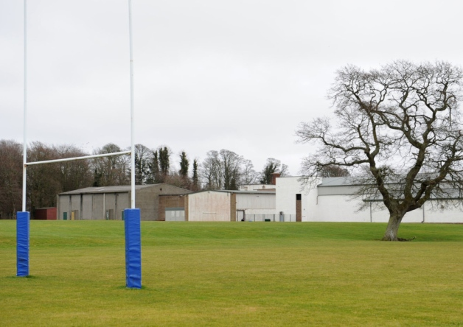
The rugby and football teams in Duns are developing new pitches behind the former Berwickshire High School.
Published on the
Published 18/01/2014 05:50
Print this
In the past two years the Blackhill Windfarm Community Fund has boosted groups in Duns and the surrounding area to the tune of nearly £148,000.
The aim of the fund, founded by Renewable Energy Systems (RES), the developers of Blackhill windfarm just north of Hardens Hill, is to aid community projects within the community council areas of Abbey St Bathans, Bonkyl and Preston, Cranshaws, Ellemford and Longformacus, Duns and Gavinton, Fogo and Polwarth.
And by the end of the last financial year the fund had gone a long way to achieving that aim, with £73,866 injected into the community.
Four of the main beneficiaries were Duns Rugby Football Club, Duns Football Club and Berwickshire Recreation Education Sport Trust (BREST) who all got £15,000 from the funding pot.
All three organisations also benefitted from the second round of funding, beginning on April 1 last year, along with six others including Duns Countdown 2000 who received £10,000 and Allsorts Nursery who were given £7,500.
The fund is managed by a board of directors, made up of one representative from each of the community councils in the Duns area; a representative of RES and independent directors not attached to a community council.
There is currently a vacancy for one of these positions and anyone interested in filling it should email fund administrator Sharon Conroy on shz_conroy@yahoo.co.uk.
The board of directors meets four times a year to review applications and welcome them from all local groups.
More information and application forms can be found at www.blackhillcommunityfund.co.uk.
Firmly of the belief that their grants have had a huge positive impact on Duns and the surrounding area, a spokesperson for Blackhill Windfarm Community Fund commented: “In challenging times, funding from all sources is key to supporting local groups and we believe that not only does our funding provide support, the availability of our funding also brings in other sources of financial support.
“Our aim is always to proactively fund projects or initiatives that have a positive long term effect on our communities and we feel that aim has been achieved.”

